ds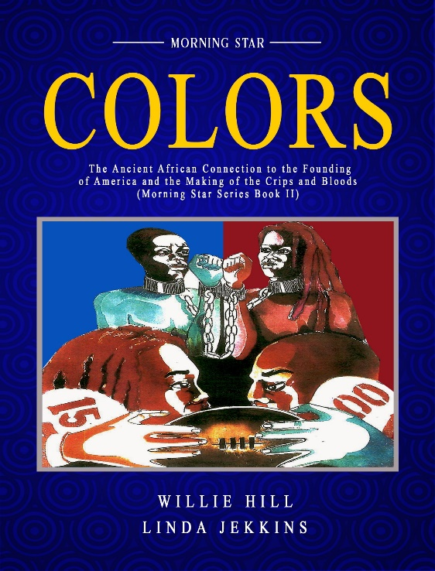

SHIP TO SHORE
By
Willie Hill
Excerpt-Chapter (satellite) of Main Manuscript (mother ship), entitled; “Color’s the Ancient African Connection to the Crips and Bloods”.
Book #2

Introduction

The age-old Crip-Blood rivalry for dominance over the inner city Hood pose no enormous danger to the rest of society at large, not like the age-old political gang truff war involving the red-rag Republican Party and the blue-rag Democratic Party rivalry for the White House that is clearly waging out of control and threating to divide US America into rival red and blue States.

This book not only reveals the pre-historical origine to the red, white and blue color phenomenon has the potential to stem the tides of gang warfare between the Crips and Bloods street gang, as well as several other street gangs that patronize the colors red and blue. It is a story linking present day Crips and Bloods with two Ancient African Warrior tribes called the Cuuzan and the Ikeely. Two Ancient African tribes who worshiped the colors red and blue for religious and ritualistic reasons. Respectively these colors held supernatural powers in the minds of these two ancient warrior tribes the Cuuzan and the Ikeely.

Long before recorded history Oral Historians introduced to the world an amazing pair of allied warrior tribes called tne Cuuzan and the Ikeely better known by their sacred comradery, “CuuIkee Allience”. Oral historians further captivate audiences with their verble commentary dramatizing the military joint ventures of the CuuIkee
Oral Historians set the stage for their ancient contepories who picked up the patoon and gave US unblemished
written commentary about ancient Black Civilazations that are mysteriously absent from contemporary His-Story (Greco/Rom crteation-foundation Myth), bookf.
Two of these Black Civilizations are well worth learning about in this never told story about the Fearless Cuuzan and the Mighty Ikeely.
Africa, at the turn of the 18th century when there was no such thing as hunger, just an overabundance of rich natural resources for foreign invaders to plunder, A God’s gift of a territory still unconquered by wealth seeking Europeans, called White Dragons with their halo of fake Christianity, and the land grabbing Arabs referred to as Brown Dragons with their sword of bogus Islam,
In a vast rich mountain-river-valley territory in Central-East Africa called the CuuIkee Nation a resistance movement was born to combat the predatory swarm, local tribespeople dobbed, , the, BDF, (Black Dragon Freedom Fighters) were as formable a military force as there ever was in Africa. Which is why the UKCI turned out being the only unconcured African Nation to come under a full scale attack from both European and Arbe land pirates at once.

“From somewhere across the western ocean a great White Dragon arrived in Africa on an in-coming wind,
One stroke of the White Dragons mighty Right wing brought on tidal waves of deception and exploitation, submerging the land of plenty and the Black African people underneath a sea of greed and upheaval,

Then... from out across the Eastern desert a mighty brown dragon crawled unto the African homeland, bearing two heads and breathing fire and burning sand,
One breath from the two-faced Brown Dragon’s fire breathing mouth scorched and set ablaze the land, burning to the ground the illustrious history and magnificent achievements of the African man,
Another fiery breath from the mouth of the 2nd face on the brown Dragon and fiery sandstorms of distortion were born, false claims to great works that wasn’t theirs, they hoped to plunge the children of the sun, into a permanent darkness of falsehood and ignorance
As African kingdoms, and great African works of art, burned in the flames, shameless forgeries rose from the ashes and laid claim to the wonders of the African man.
Then came a mighty rumbling from out across the untouched heartland, and a Black Dragon +appeared to take a stand. The Black Dragon was the Ikeely and the Cuuzan,

Two young warrior apprentices named Tuuwee Cuuzan and a young Ikeely warrior named Luba Zandi were captured in battle, enslaved and carted off to America aboard a slave ship named The Duchess.

The moon was full; around midnight when an oar-driven Dutch War Galley armed to the teeth on all sides crept slowly in from the dark empty abyss of the Atlantic Ocean. Like a ghostly shadow against the backdrop of the moon, the heavily armed Dutch Fighter lurked its way slowly along the outer perimeter of the sleepy back-water harbor just outside New Orleans, Louisiana sometime during the decade leading up to the start of the civil war in 1861. She bore the name “Duchess”, spelled out on both sides of her stern. And she was armed with 8 canons and 4 big guns mounted, two each, on the bow and on the stern. Two guns flanked an imposing large hard-wood statue of a mermaid leaning forward off the stern with her cupped hands and arms stretched out in a diving position,
The 8 canons were pulled up to their port-holds, ready to fire on command at the first sight of a U.S. Navy Patrol ship as the mysterious Duchess moved stealthy across the water under a cloud of suspicion. The “Transportation of Raw Slaves across the Atlantic was a Hangings Offence by 1861, and Pirate smugglers would rather die fighting then be hanged.
On board were xll mxanner of illegal human cargo, dozzens of black African men and womanof all ages Tuuwee and Luba arrived in America, the best of friends, allies for life by sacred God ordained Decree, two disciples of their perspective ancestral religious practices. They were forcefully uprooted from their native land of birth and ancestral religious worship and planted in a ruthless land still unsettled in religious morality. Thousands of miles from home all Tuuwee and Luba had was each other and their individual ancestral religious devotion to a pair of sacred colors, undying faith in the mystical power of blue and red, colors that connected them symbolically to their ancestors’ long dead but vehemently never forgotten and devoutly worshipped.
Yet today several generations after the landing of these two patriarchs of the red and blue sacred symbol of King Narmer’s famous “Unification of the Two Lands of God” has been desecrated, their legacy of friendship and sacred tribal alliance and shared citizenship as members of the CuuIkee Nation. It was viscously severed with far reaching violent effect that symbolically has spouted out to this very day into quarrelsome deadly groups of gangsters called the Crips who patronize the sacred color blue and their bitter rival the Bloods disciples of the sacred color red.
If any one reason for the estrangement of the sacred red and blue legacy of Unity can begin to be unraveled, we would have to go back in time to the moment and place when Tuuwee and Luba first arrived in America in the predawn hours aboard an illegal slave ship where quietly they were offloaded from the Ship to a secret landing on Shore somewhere outside New Orleans. Here slave and slave master first met to wed in unholy matrimony of torturous servitude and greedy convenience.
Twelve smartly dressed white men were gathered in back of a loading dock, all of them rich Southern flesh buyers, wearing silk suits and plush beaver skin top hats and carrying gold plated walking canes. They looked like peacocks on a chicken farm standing around an auction block platform in the midst of a dirty fish smelling seaport.
Owning domesticated Slaves as property was still legal in 14 of the 50 states of America at the time. But the transportation of Africans across the Atlantic Ocean was outlawed. Pure greed, and lack of respect for existing slave laws drove these plantation owners to this filthy fish smelling back loading dock were once a week or so a ship load of illegal raw natives, usually more dead than alive, would arrive at this secret location.
The crowd of flesh buyers gathered around the elevated auction platform as dock workers wearing greasy overalls went about their daily labors loading and unloading cargo ships and horse driven flatbed wagons totally ambiguous of the fancy dressed congregation of rich southern gentlemen. And, in turn, the group of Southern Aristocrats ignored their dirty low class waterfront work force. Only one thing was on the mind of these rich slave buyers, out bidding the next fellow for the cream of the human crop that was about to be off loaded from the newly arrived slave ship called the “Duchess”.
Most of these men were big production plantation owners, and what they wanted was healthy and strong looking Black males and females, who they call, Bucks and Wenches, that show signs of having at least 15 years of production, laboring in the cotton, tobacco, and sugarcane fields.
Luba Zandi, the red head Ikeely warrior, with the overbearing rope size dreadlocks, and Tuuwee Cuuzan, the blue warrior prince of the mighty Cuuzan, chained together side by side, were herded from the slave ship onto the loading dock like common cattle. As the slave auction began Tuuwee and Luba were put on the stand. They were irresistible to any flesh buyer, chained together they were purchased as a pair, but all that changed the minute they tried to cut Luba’s red dreadlock hair.
Tuuwee and Luba became bought pieces of property to a wealthy plantation owner, ironically named Jay Fullove.
Luba’s long red hair was just too intimidating a sight to bare, even in the cold spiritless eyes of Jay Fullove and his pair of brutish, cold-blooded henchmen. Immediately, Jay Fullove ordered his henchmen to shave Luba’s red locks. Luba resisted and was brutally assaulted on the spot.
They had taken him from his home and family and now they wanted to strip him bare from the symbol of his manhood, his red hair. It was the silent but bold expression of his warrior pride, his badge of honor, his only symbolic connection to his god.
One of the henchmen looked Luba in the eye and warned: “Submit to the will of your new master or die!”
Consequently, Luba was beaten within an inch of his life. One more blow and it would have been curtains for the brave young Ikeely.
Tuuwee Cuuzan, the blue Cuuzan warrior prince, realized that his dear Ikeelian friend would rather die than submit.
Prince Tuuwee stoutheartedly intervened. Remembering the CuuIkee pledge of allegiance to each other. he deliberately stepped in and took that punishing death blow that was meant for his friend and ally lying helpless on the dirty wet ground.
Tuuwee paid a physically bruising price, but it was worth saving his comrades life.
But for slave master Jay Fullove, such an act of loyalty between slaves, was unheard of.
In the end the blue warrior prince of the mighty Cuuzan, and the red head Ikeelian were separated right there where their wretched American legacy began.
Slave master Fullove promptly resold Luba, making certain that the second buyer was an outer towner. Jay Fullove expounded on his decision with these momentous words and this revealing admission,
“Gentlemen”, he said to the crowd of flesh buyers, “We have just witnessed an occurrence unbefitting of niggers. I myself refuse to have in my stable any semblance of niggard comradery behavior. Now, if any party is interested, the blue nigger, I just purchased is now up for resell at the low price of half what I myself just paid but mind you this offer is good only to an out-of-state buyer. These two niggers should never be allowed together in the same state, least of all the same plantation stable.
Thus was the arrival of the red and blue COLOR phenomenon.

