;

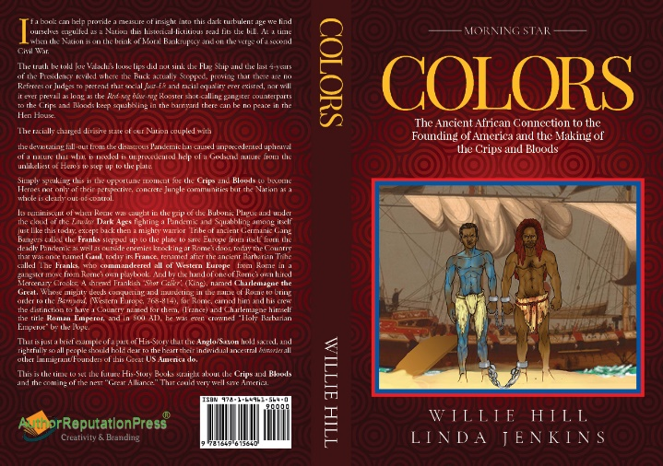

**COLORS**

**AN ANCIENT FORGOTTEN xTRUTH**

**WHY WE SHOULD VOTE**

**BY**

**WILLIE HILL**

Historically, Slave Masters have tried in vain to suppress African heritage by any means, but for all their Diabolical scheming they couldn’t take away black people’s identity, nor stop the spread of our knowledge of Self and the significant role our ancient ancestors played in shaping the genesis of Human Civilization itself.

With roots in tack this self-empowering Cultural Identity was torn from the bosom of the mother country, it arrived in America chained, shackled, and physically more dead than alive, yet mechanical restraints and physical helplessness proved obsolete, and the real threat of Black self-knowledge landed unchecked, instilled in the hearts and minds of the enslaved die-hard host carriers.

Wherever the knowledge landed, on whatever plantation it was planted it grew and secretly spread like wildfire into a self-empowering pandemic that infected the likes of Fredric Douglas and Harriet Tubman, who became host carriers of the white man’s worst nightmare, that mushroomed through the generations from the Southern plantations to the Northern ghetto streets.

By the time the slavers awakened to the threat the Black self-enlightenment found its way into the brave hearts and charismatic minds of Malcom X and Dr. Martin Luther King. Together their “Truth-To-Power” woke up America overshadowing the primitive intellect of the beast with the very same knowledge that gave rise to ancient Greece.

To the dismay and disbelief of the anti-progressive Elite, the enslaved Black Africans that they commandeered to America were people cut from the original Tree of Knowledge that provided the ancient Greek builders with the secrete Fruits of Egyptian engineering used to turn Greek village communities into cities and then a Nation, and finally the empire that Greeks falsely claimed was the first empire in His-Story, (Greco/Roman creation-foundation Myth).

But the fact is, history revial that all knowledge known to man was born from the womb of the Motherland, thus the famous Greek Scholars, Plato, Socrates, and Aristotle, in search of the world’s Mysterys all turned to Africa for knowledge. They sailed the perilous seas and crossed extreme desert turan to go to Africa and spend years studying at the feet of black Master’s of the Mysteres.

Liberal arts, Philosophy, Agriculture, and Mathematics, as well as secrete Academics in Esoteric Religion, Alchemy, Astrology, and the pre-history of the World they stole.

These great seekers of wisdom, knowledge and understanding returned to Greece from Africa where they (Then), opened up Mystery Schools of their own and taught their fellow countrymen what they gleamed from a land they initially labeled the “Dark Continent”.

And now the age-old agenda to quell this Knowledge is still alive and well, being perpetrated to keep the modern-day Wage-Slave ignorant and Subservient to the will of the Ruling Class Hierarchy, to deny, and/or, miseducate the Mass’ with off-the-wall hypocritical fear tactics.

Behind the Smoke Screen called “Critical Race Theory”, a crime is being committed to outlaw the teaching of history, and anyone not in line with the corruption is an enemy to the “Powers-That-Be”.

We must ignore the distractions being thrown in our path aimed at disrupting our progress and stealing our attention away from the real, “Critical Race War Agenda”.

Let’s not keep being fooled creating our own distractions, every time they attack we run to the town square for public debate wasting valuable time trading views about what’s on the enemy’s mind, and running to the Senate floor to argue and plead for tougher gun control laws, something we will never get, nor will we get back what laws they took, and are steadily taking all the while we spend time begging.

Our fighting forces are positioned right were the enemy want us, “on the sideline watching and waiting for the next hammer to drop”. The old In-your-face, *“disrupt* *and confuse”,* method of diversion, while going about the bigotry business of “burning history books” and passing “Voter Suppression Laws.”

The anti-progressive forces will do anything to keep us from progressing.

Their greatest fear is knowledge of history in the hands of today’s independent minded Youth generation. regardless of race, creed, or color and especially the “Other”, who the enemy fear most of all, the up-and-coming Immigrant generation of people of color, the future community of young voters.

The hidden “Race War Agenda is being revealed in plain sight with each diabolical in-your-face act of war by certain die-hard forces of the past election that simply refuse to accept their last defeat at the ballet box.

Yet we mustn’t feed into their “Race War Agenda,” if we dare do so we’ve already lost the war. Remember who got all the guns, “their only weapon”, to speak of. Yet never forget who got the greatest weapon of all, Our VOTE, and our education passed down from our Civil Rights predecessors who won them both fair and square at the ballet box. And now its up to our Elders to pass the weapon to our youth generation who are the “silver bullets” that will eventually take the enemy out of the fight before they can justifiably use their weapons for any lasting effect, let-alone permanent victory.

Remember our vanguard predecessors didn’t bring us this far with guns blazing in broad daylight and public lynching in the streets. And they surely wouldn’t want to see us throw away all the progress that they fought and died for through our rash vigilante behavior.

We must seize the present with an iron will to preserver with patience, as a cohesive force of many, task with the single-minded objective to weaponize our youth with self-knowledge, facts about His-Story, and how to VOTE.

Make good of every moment, in-between the enemy’s cowardly attacks to school our youth on how our predecessors over-came, that we may over-come by way of the none-violent response, and by way of the ballet box.

Thus, safeguarding our future, and preserving our Nations democracy, as we march toward our next history-making victory.

Willie Hill B-58763

(415) 368-6686

Williehill1953@yahoo.com

|  |  |
| --- | --- |
| **ARP Website** | <https://authorreputationpress.com/product/colors-the-ancient-african-connection-to-the-founding-of-america-and-the-making-of-the-crips-and-bloods/> |
| **Amazon** | [*https://amzn.to/3EZO5uY*](https://amzn.to/3EZO5uY) |
| **Barnes and Noble** | [*https://bit.ly/3CYYZ2d*](https://bit.ly/3CYYZ2d) |

Facebook ( https://www.facebook.com/Author-Willie-Hill-103031722164962 )

Twitter ( https://twitter.com/WillieAuthor )